
American International University- Bangladesh (AIUB) Faculty of Engineering (FE)

Course Name: | DATA COMMUNICATION | Course Code: | COE3103
Semester: | Spring 2024-25 | Section: | L
Faculty: | DR. AMIRUL ISLAM | Group: | 08
Experiment No: | 08
Experiment Name: | Study of Frequency Division Multiplexing (FDM) using MATLAB

Submitted by (NAME): | FAHMIDA RAHMAN | Student ID: | 22-48483-3
Group Members |  | Name | ID
 | 1. | MD. MIRAN HOSSAIN | 22-46175-1
 | 2. | FAHMIDA RAHMAN | 22-48483-3
 | 3. | MOHSIN IBNA HOSSAIN | 23-50194-1
 | 4. | MD. YEAHYEA JAM | 23-50187-1
 | 5. | HOSSAIN MOHAMMAD SAMI | 23-51354-1

Performance Date: | 12/05/2025 | Due Date: | 19/05/2025
Marking Rubrics (to be filled by Lab Instructor)
Category | Proficient [6] | Good [4] | Acceptable [2] | Unacceptable [1] | Secured Marks
Theoretical Background, Methods & procedures sections | All information, measures and variables are provided and  explained. | All Information provided is sufficient, but more explanation is  needed. | Most information is correct, but some information may be  missing or inaccurate. | Much information is missing and/or inaccurate.
Results | All of the criteria are met; results are described clearly and accurately; | Most criteria are met, but there may be some lack of clarity and/or incorrect information. | Experimental results don’t match exactly with the theoretical values and/or analysis  is unclear. | Experimental results are missing or incorrect;
Discussion | Demonstrates thorough and sophisticated understanding.  Conclusions drawn are appropriate for  analyses; | Hypotheses are clearly stated, but some concluding statements not supported by data or data not well  integrated. | Some hypotheses missing or misstated; conclusions not supported by data. | Conclusions don’t match hypotheses, not supported by data; no integration of data from different sources.
General formatting | Title page, placement of figures and figure captions, and other  formatting issues all correct. | Minor errors in formatting. | Major errors and/or missing information. | Not proper style in text.
Writing & organization | Writing is strong and easy to understand; ideas are fully elaborated and connected; effective transitions between sentences; no  typographic, spelling, or grammatical errors. | Writing is clear and easy to understand; ideas are connected; effective transitions between sentences; minor typographic, spelling, or grammatical errors. | Most of the required criteria are met, but some lack of clarity, typographic, spelling, or grammatical errors are present. | Very unclear, many errors.
Comments: |  |  |  | Total Marks (Out of 30):

Title
Study of Frequency Division Multiplexing (FDM) using MATLAB
Abstract:
This experiment is designed to-
1. To understand the use of MATLAB for solving communication engineering problems.
2. To develop understanding of FDM concept and how to implement it in Matlab.
Introduction:
Frequency-division multiplexing (FDM) is an analog technique that can be applied when the bandwidth of a link (in hertz) is greater than the combined bandwidths of the signals to be transmitted. In FDM, signals generated by each sending device modulate different carrier frequencies. These modulated signals are then combined into a single composite signal that can be transported by the link. Carrier frequencies are separated by sufficient bandwidth to accommodate the modulated signal. These bandwidth ranges are the channels through which the various signals travel. Channels can be separated by strips of unused bandwidth—guard bands— to prevent signals from overlapping. In addition, carrier frequencies must not interfere with the original data frequencies.
Figure 1 gives a conceptual view of FDM. In this illustration, the transmission path is divided into three parts, each representing a channel that carries one transmission.
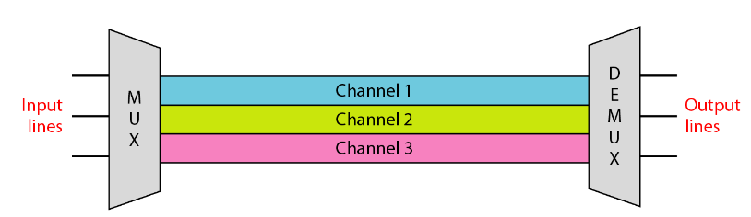
Fig-1: Frequency Division Multiplexing (FDM)
Multiplexing Process: Figure 2 is a conceptual illustration of the multiplexing process. Each source generates a signal of a similar frequency range. Inside the multiplexer, these similar signals modulate different carrier frequencies ( f1, f2, and f3). The resulting modulated signals are then combined into a single composite signal that is sent out over a media link that has enough bandwidth to accommodate it
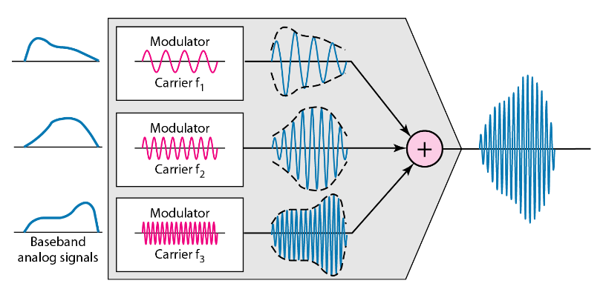
Fig-2: Multiplexing Process in FDM
Demultiplexing Process: The demultiplexer uses a series of filters to decompose the multiplexed signal into its constituent component signals. The individual signals are then passed to a demodulator that separates them from their carriers and passes them to the output lines. Figure 3 is a conceptual illustration of demultiplexing process.
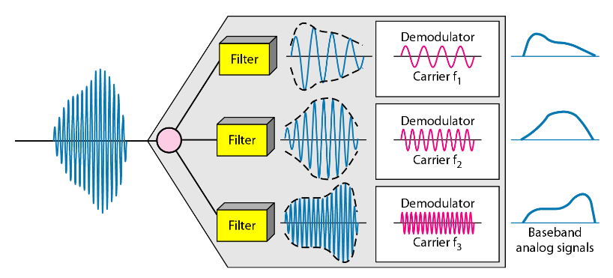
Fig-3: De-multiplexing Process in FDM
Results and Discussion
a) mt1 = am1*cos(2*pi*fm1*t); b) mt2 = am2*cos(2*pi*fm2*t); c) mt3 = am3*cos(2*pi*fm3*t); d) mt4 = am4*cos(2*pi*fm4*t); where, am1 = (F+2); am2 = (F+5); am3 = (F+8); am4 = (F+11); and fm1 = (G+1); fm2 = (G+2); fm3 = (G+3); fm4 = (G+4); We want to simultaneously transmit these four signals through a single data link that can support a frequency range of 50 Hz to 250 Hz. Write a code that can modulate and multiplex the four given message signals in transmitting side (use appropriate carrier signals for amplitude modulation as required) and de-multiplex (use appropriate cut off frequencies in your bandpass filters) and de-modulate (use appropriate cut-off frequencies in your lowpass filters) to recover the four message signals in receiving side
Code:
clc;
clear all;
close all;

%// Parameters from ID
F = 8;
G = 3;

am1 = F + 2; fm1 = G + 1; % am1 = 10, fm1 = 4
am2 = F + 5; fm2 = G + 2; % am2 = 13, fm2 = 5
am3 = F + 8; fm3 = G + 3; % am3 = 16, fm3 = 6
am4 = F + 11; fm4 = G + 4; % am4 = 19, fm4 = 7

%// Sampling
fs = 4001;
t = 0:1/fs:1-1/fs;

%// Message Signal Generation
mt1 = am1 * cos(2*pi*fm1*t);
mt2 = am2 * cos(2*pi*fm2*t);
mt3 = am3 * cos(2*pi*fm3*t);
mt4 = am4 * cos(2*pi*fm4*t);

%// Carrier Signal Generation
fc1 = 50; c1 = cos(2*pi*fc1*t);
fc2 = 100; c2 = cos(2*pi*fc2*t);
fc3 = 150; c3 = cos(2*pi*fc3*t);
fc4 = 200; c4 = cos(2*pi*fc4*t);

%// Modulation (DSB-SC)
s1 = mt1 .* c1;
s2 = mt2 .* c2;
s3 = mt3 .* c3;
s4 = mt4 .* c4;

%// Composite Signal
x = s1 + s2 + s3 + s4;

%// Time Domain Plots of Message Signals
figure;
subplot(4,1,1); plot(t, mt1); title('Message Signal 1'); ylim([-am1 am1]);
subplot(4,1,2); plot(t, mt2); title('Message Signal 2'); ylim([-am2 am2]);
subplot(4,1,3); plot(t, mt3); title('Message Signal 3'); ylim([-am3 am3]);
subplot(4,1,4); plot(t, mt4); title('Message Signal 4'); ylim([-am4 am4]);

%// Frequency Domain of Message Signals
f = fs/2 * linspace(-1,1,fs);
M1 = abs(fftshift(fft(mt1)))/(fs/2);
M2 = abs(fftshift(fft(mt2)))/(fs/2);
M3 = abs(fftshift(fft(mt3)))/(fs/2);
M4 = abs(fftshift(fft(mt4)))/(fs/2);

figure;
subplot(4,1,1); stem(f, M1); title('Message Signal 1 Spectrum'); xlim([-10 10]);
subplot(4,1,2); stem(f, M2); title('Message Signal 2 Spectrum'); xlim([-10 10]);
subplot(4,1,3); stem(f, M3); title('Message Signal 3 Spectrum'); xlim([-10 10]);
subplot(4,1,4); stem(f, M4); title('Message Signal 4 Spectrum'); xlim([-10 10]);

%// Composite Signal Time & Frequency
X = abs(fftshift(fft(x)))/(fs/2);
figure;
subplot(2,1,1); plot(t, x); title('Composite Signal in Time Domain');
subplot(2,1,2); stem(f, X); title('Composite Signal Spectrum'); xlim([-250 250]);

%// Bandpass Filtering
[b1, a1] = butter(5, [(fc1-fm1-6)/(fs/2), (fc1+fm1+6)/(fs/2)]);
[b2, a2] = butter(5, [(fc2-fm2-6)/(fs/2), (fc2+fm2+6)/(fs/2)]);
[b3, a3] = butter(5, [(fc3-fm3-6)/(fs/2), (fc3+fm3+6)/(fs/2)]);
[b4, a4] = butter(5, [(fc4-fm4-6)/(fs/2), (fc4+fm4+6)/(fs/2)]);

bpf1 = filter(b1, a1, x);
bpf2 = filter(b2, a2, x);
bpf3 = filter(b3, a3, x);
bpf4 = filter(b4, a4, x);

%// Mixing with Carrier
z1 = 2 * bpf1 .* c1;
z2 = 2 * bpf2 .* c2;
z3 = 2 * bpf3 .* c3;
z4 = 2 * bpf4 .* c4;

%// Lowpass Filters
[lp1_b, lp1_a] = butter(5, (fm1+3)/(fs/2));
[lp2_b, lp2_a] = butter(5, (fm2+3)/(fs/2));
[lp3_b, lp3_a] = butter(5, (fm3+3)/(fs/2));
[lp4_b, lp4_a] = butter(5, (fm4+3)/(fs/2));

rec1 = filter(lp1_b, lp1_a, z1);
rec2 = filter(lp2_b, lp2_a, z2);
rec3 = filter(lp3_b, lp3_a, z3);
rec4 = filter(lp4_b, lp4_a, z4);

%// Time Domain Plots of Recovered Signals
figure;
subplot(4,1,1); plot(t, rec1); title('Recovered Signal 1'); ylim([-am1 am1]);
subplot(4,1,2); plot(t, rec2); title('Recovered Signal 2'); ylim([-am2 am2]);
subplot(4,1,3); plot(t, rec3); title('Recovered Signal 3'); ylim([-am3 am3]);
subplot(4,1,4); plot(t, rec4); title('Recovered Signal 4'); ylim([-am4 am4]);

%// Frequency Domain of Recovered Signals
R1 = abs(fftshift(fft(rec1)))/(fs/2);
R2 = abs(fftshift(fft(rec2)))/(fs/2);
R3 = abs(fftshift(fft(rec3)))/(fs/2);
R4 = abs(fftshift(fft(rec4)))/(fs/2);

figure;
subplot(4,1,1); stem(f, R1); title('Recovered Signal 1 Spectrum'); xlim([-10 10]);
subplot(4,1,2); stem(f, R2); title('Recovered Signal 2 Spectrum'); xlim([-10 10]);
subplot(4,1,3); stem(f, R3); title('Recovered Signal 3 Spectrum'); xlim([-10 10]);
subplot(4,1,4); stem(f, R4); title('Recovered Signal 4 Spectrum'); xlim([-10 10]);

Result and Discussion:
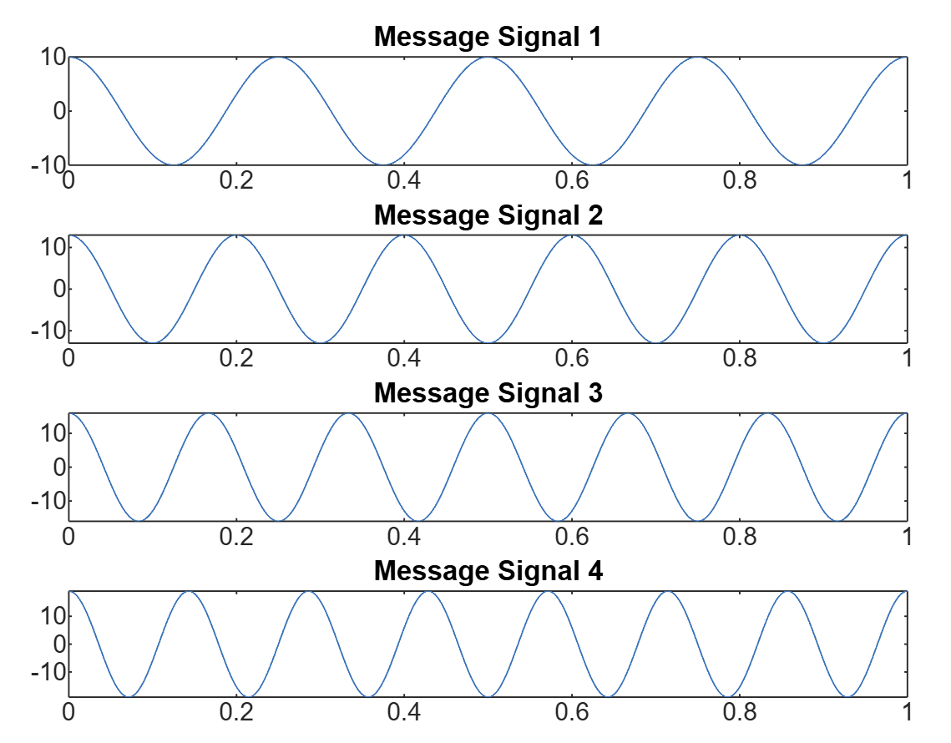
Fig4: Time Domain Plots of Message Signals
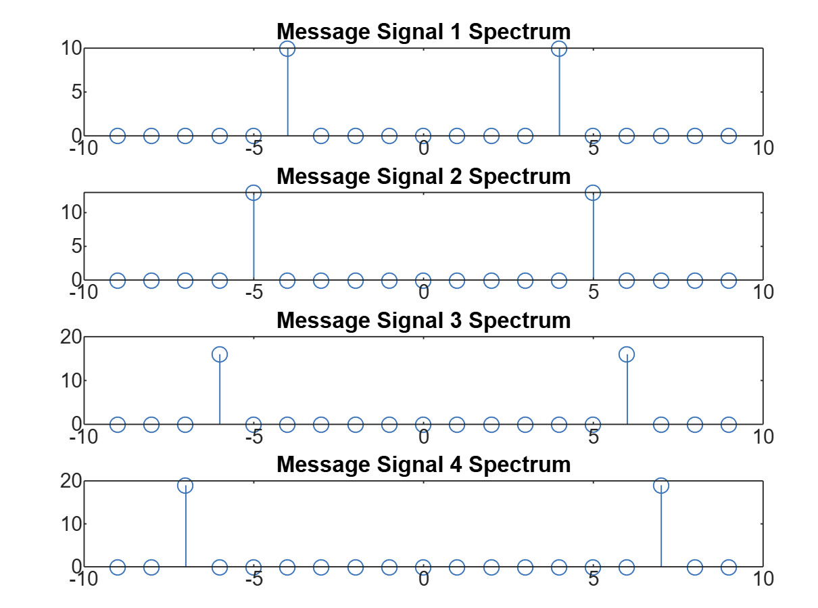
Fig5: Frequency Domain of Message Signals
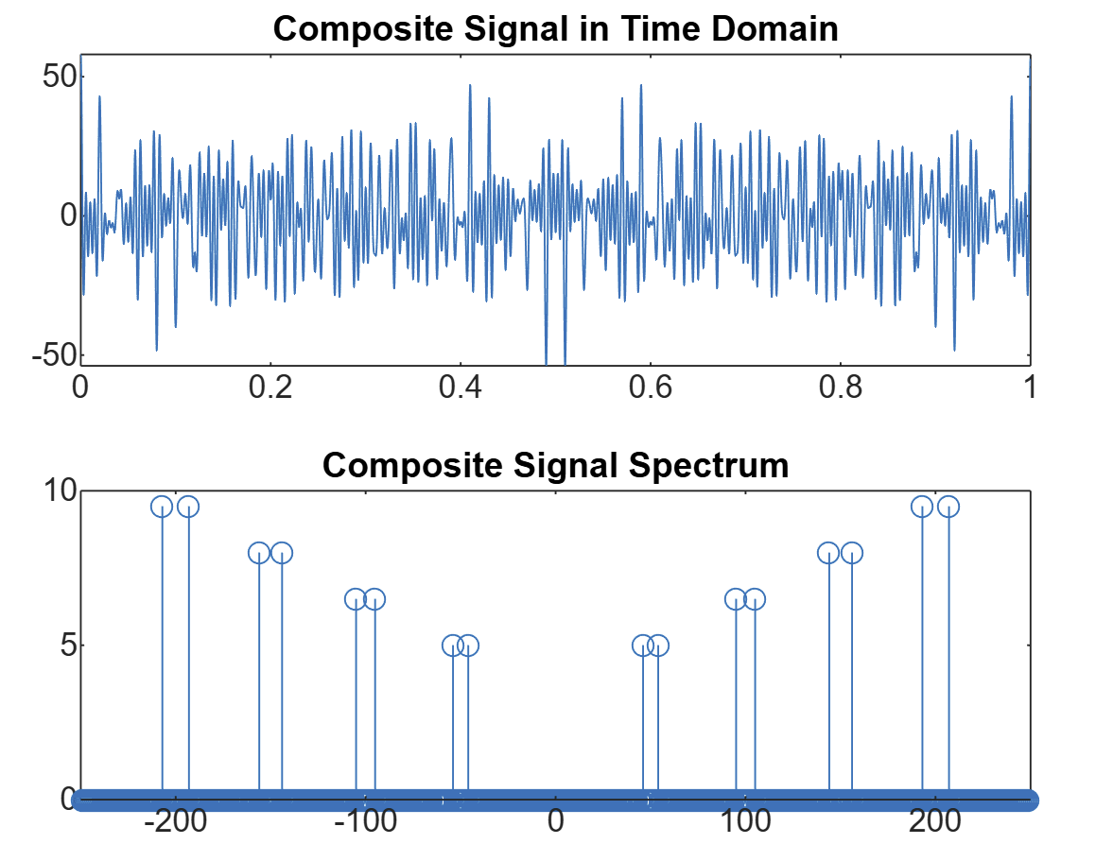
Fig6: Composite Signal – Time & Frequency Domain
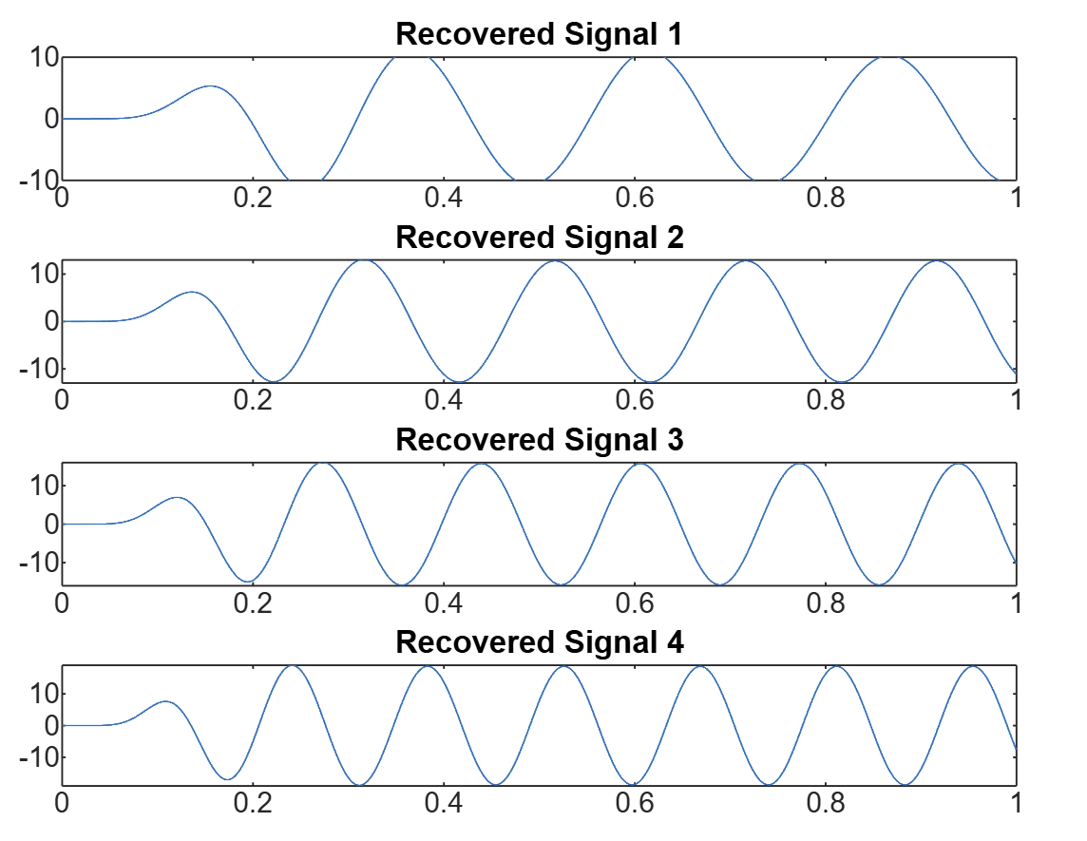
Fig7: Composite Signal – Time & Frequency Domain
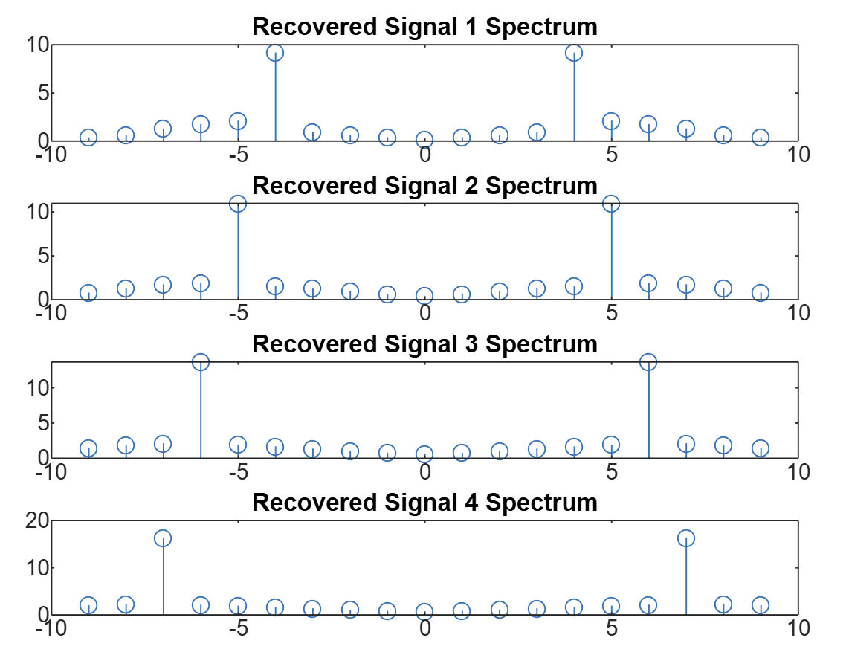
Fig8: Frequency Domain of Recovered Signals
This experiment effectively demonstrated the concept of Frequency Division Multiplexing (FDM) using MATLAB by transmitting multiple signals over a single channel. Four message signals, each with unique amplitude and frequency values, were generated and modulated using DSB-SC amplitude modulation onto separate carrier frequencies. The chosen carrier frequencies (50 Hz, 100 Hz, 150 Hz, and 200 Hz) provided sufficient spacing to prevent spectral overlap, which is essential for proper multiplexing.
The modulated signals were combined into a composite signal that represented the multiplexed data stream. Analysis of the composite signal in both time and frequency domains showed distinct frequency components for each modulated signal, validating the effectiveness of the modulation and multiplexing process. At the receiving end, bandpass filters were used to isolate individual channels, followed by coherent demodulation and lowpass filtering to successfully recover each original message signal.
The recovered signals closely matched the original inputs, indicating minimal distortion and successful transmission through the simulated FDM system. Any minor discrepancies could be due to filter imperfections or limitations in frequency separation. This experiment highlighted the importance of careful carrier frequency selection and proper filter design in FDM systems, emphasizing how MATLAB can be a powerful tool for simulating and analyzing complex communication processes.

Conclusion
This experiment successfully illustrated Frequency Division Multiplexing (FDM) using MATLAB. Four distinct message signals were modulated onto different carrier frequencies and combined into a single composite signal. At the receiver end, proper filtering and demodulation allowed accurate recovery of the original signals.
The results confirmed the effectiveness of FDM when carrier frequencies and filters are carefully chosen. Overall, the experiment provided practical understanding of multiplexing techniques and the role of MATLAB in simulating communication systems.

